Validity Evidence for mCLASS®:Reading 3DTM and Student Performance on the 2012-2013 North Carolina End of Grade Reading Comprehension Test
Introduction
This study investigates the validity evidence for mCLASS®:Reading 3D™ — comprised of DIBELS Next® and Text Reading and Comprehension (TRC) — in concurrence with student outcomes on the North Carolina End-of-Grade Reading Comprehension Test (NC EOG). Comparisons of the outcomes of one assessment (i.e., NC EOG) with the results of one or more other assessments (i.e., DIBELS Next, TRC) and the relationships among these assessments are typically examined via descriptive statistics, cross-tabulations, correlations, and logistic regression models; this is the approach followed in this study.
Measures
DIBELS Next is a set of procedures and measures for assessing the acquisition of early literacy skills from kindergarten through grade 6. By the end of grade 3 (3EOY), students are designated as Well Below Benchmark, Below Benchmark, or Benchmark on DIBELS Next based on the application of the cut scores provided in Table 1 to their Composite Scores.

Table 1: DIBELS Next Cut Points for Grade 3 End of Year
Benchmark Status | Composite Score
Well Below Benchmark | ≤ 279
Below Benchmark | 280–329
Benchmark | ≥ 330

TRC is a Running Record measure of text reading accuracy and comprehension that is individually administered to students using a handheld device. The TRC outcomes of interest in the current study are the final instructional text level and performance level, specific to 3EOY. Students who demonstrate instructional performance at book levels in various leveled ranges are classified as Far Below Proficient, Below Proficient, Proficient, and Above Proficient. Table 2 provides the 3EOY TRC cut points applied to the Rigby book set used in NC.

Table 2: TRC Cut Points for Grade 3 End of Year
Performance Level | Book Level
Far Below Proficient | ≤ M
Below Proficient | N-O
Proficient | P-Q
Above Proficient | ≥ R

The North Carolina End-of-Grade Reading Comprehension Tests (NC EOG) are administered within the last three weeks of each school year from grades 3–8 (North Carolina Department of Public Instruction, 2009). Four scale score ranges were established to determine a student’s achievement level, which indicates the degree to which a student is prepared to succeed at the next grade level. A student who scores at achievement Level I or Level II shows limited or partial command of the knowledge and skills contained in the Common Core State Standards (CCSS) Reading Standards for Literature, Informational Text, and Language. A student who scores at achievement Level III or Level IV shows solid or superior command of the knowledge and skills contained in the Common Core State Standards (CCSS) Reading Standards for Literature, Informational Text, and Language. Grade 3 students in North Carolina are required to score at achievement Level III or above in order to continue on to grade 4 in the next school year. Table 3 provides the scaled score cut points for each of the performance levels for the grade 3 NC EOG.

Table 3: NC EOG Reading Comprehension Test Cut Points for Grade 3
Performance Level | EOG Scaled Score
Level I | ≤ 431
Level II | 432–441
Level III | 442–451
Level IV | ≥ 452
Sample
Of the 64,515 unique grade 3 students assessed using mCLASS:Reading 3D in the spring of the 2012–2013 school year, 56,999 students provided complete DIBELS Next and TRC results. The mCLASS:Reading 3D data were then matched to the full ‘12–‘13 NC EOG data (n = 102,780 unique students). Of the complete mCLASS: Reading 3D data, 53,890 unique students were matched to their NC EOG data, yielding a 95 percent match rate. This matched sample contains 850 schools; 49 percent of the student sample is female and 51 percent is male; 50 percent of the students identify as White, 26 percent as Black or African American, 16 percent as Hispanic or Latino, and 4 percent as Multiracial.

Results
Analysis 1: Describing and Correlating mCLASS:Reading 3D and NC EOG Performance
Table 5 summarizes descriptive statistics for DIBELS Next Composite Scores and TRC final instructional reading levels at 3EOY and NC EOG scaled scores. The TRC text levels were converted to numeric values to facilitate analysis (PC = 2, RB = 3, A = 4, B = 5, C = 6, D = 7, E = 8, F = 9, G = 10, H = 11, I = 12, J = 13, K = 14, L = 15, M = 16, N = 17, O = 18, P = 19, Q = 20, R = 21, S = 22, T = 23, U = 24, V = 25, W = 26.).

Table 5: Descriptive Statistics for DIBELS Next Composite Score, TRC Level, NC EOG Reading Assessment Scale Score.
Measure | Mean | SD | Median | Minimum | Maximum
DIBELS Next | 375.25 | 119.43 | 379 | 0 | 815
TRC* | 19.10 (P) | 3.99 | 20 (Q) | 2 (PC) | 24 (U)
NC EOG | 439.03 | 10.15 | 440 | 406 | 462
* Numeric equivalents presented with alphabetic text levels in parentheses.

Table 6 presents correlations among DIBELS Next Composite Score, TRC, and NC EOG. The correlations with NC EOG were strong for both TRC final instructional reading level (r = 0.71, p < 0.05) and DIBELS Composite Score (r = 0.74, p < 0.05).

Table 6: Correlations between DIBELS Next Composite Score, TRC Level, and NC EOG Reading Assessment Scale Score.
Measure | DIBELS NEXT | TRC
DIBELS Next | — | 0.72*
TRC | 0.72* | —
NC EOG | 0.74* | 0.71*
* p < 0.05.

Table 7 presents the frequency with which students in each DIBELS Next benchmark status category (Well Below Benchmark, Below Benchmark, and Benchmark) and TRC performance level category (Far Below, Below, Proficient, and Above) achieved scores within each performance level on NC EOG. Additionally, percentages of students in each NC EOG performance level for each combination of DIBELS Next and TRC performance level are presented.

Figure 1 presents these results graphically. Each of the vertical bars displays the percentage of students at each NC EOG performance level for the combinations of DIBELS Next and TRC performance levels. Above the bars, each window in the graphic corresponds to DIBELS Next performance levels while the values below the horizontal axis indicate the TRC performance levels.

Generally, as student performance increases on both DIBELS Next and TRC, so too does performance on NC EOG. Of note, those students who performed highest on both DIBELS Next and TRC demonstrated the highest rate of achieving Level IV on the NC EOG (22%). All other performance on DIBELS Next and TRC yielded much lower rates of Level IV outcomes on NC EOG (0–5%)

A chi-squared test of independence indicates that the frequency distribution of performance levels on the NC EOG significantly relates to DIBELS Next and TRC performance levels (χ² = 89,485, df = 39, p < 0.05).

Table 7: Distribution of NC EOG Performance Levels by Combined DIBELS Next and TRC Performance Levels
 |  | NC EOG (Freq.) |  |  |  |  | NC EOG (%)
DIBELS Next | TRC | 1 | 2 | 3 | 4 | Total | 1 | 2 | 3 | 4
Well Below | Far Below | 5789 | 1225 | 64 | 0 | 7078 | 82% | 17% | 1% | 0%
 | Below | 1078 | 703 | 78 | 1 | 1860 | 58% | 38% | 4% | 0%
 | Proficient | 341 | 394 | 65 | 2 | 802 | 43% | 49% | 8% | 0%
 | Above | 87 | 160 | 37 | 2 | 286 | 30% | 56% | 13% | 1%
Below | Far Below | 1219 | 1070 | 144 | 2 | 2435 | 50% | 44% | 6% | 0%
 | Below | 674 | 1086 | 267 | 16 | 2043 | 33% | 53% | 13% | 1%
 | Proficient | 380 | 991 | 326 | 10 | 1707 | 22% | 58% | 19% | 1%
 | Above | 182 | 608 | 325 | 31 | 1146 | 16% | 53% | 28% | 3%
Benchmark | Far Below | 803 | 1791 | 562 | 32 | 3188 | 25% | 56% | 18% | 1%
 | Below | 677 | 2382 | 1275 | 83 | 4417 | 15% | 54% | 29% | 2%
 | Proficient | 576 | 3577 | 3255 | 408 | 7816 | 7% | 46% | 42% | 5%
 | Above | 402 | 4774 | 11264 | 4672 | 21112 | 2% | 23% | 53% | 22%
Total | Total | 12208 | 18761 | 17662 | 5259 | 53890 | 23% | 35% | 33% | 10%

Figure 1: Percentage of Students in NC EOG Performance Levels by DIBELS Next Benchmark Status and TRC Performance Level
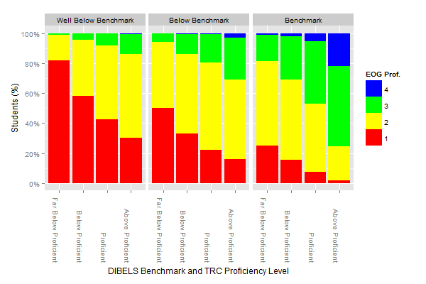
More simply, Table 8 presents the cross-tabulation of DIBELS Next, TRC, and NC EOG performance according to proficiency status only. For this analysis, students were classified as proficient if they reached Benchmark on DIBELS Next or Proficient/Above Proficient on TRC; each measure represents separate proficiencies, so students could be proficient on neither, one, or both measures. For the NC EOG, proficiency is defined as achieving Level III or IV.

It is clear from the results in Table 8 that students who were non-proficient on both DIBELS Next and TRC were also non-proficient on the NC EOG (96%). Also, proficiency on both DIBELS Next and TRC strongly corresponds to proficiency on the NC EOG (68%).

Table 8: Distribution of Proficiency across NC EOG, DIBELS Next, and TRC Performance Levels
 |  | NC EOG (Freq.) |  |  | NC EOG (%)
DIBELS Next | TRC | Non-Prof. | Proficient | Total | Non-Prof. | Proficient
Non-Prof. | Non-Prof. | 12844 | 572 | 13416 | 96% | 4%
 | Proficient | 3143 | 798 | 3941 | 80% | 20%
Proficient | Non-Prof. | 5653 | 1952 | 7605 | 74% | 26%
 | Proficient | 9329 | 19,599 | 28,928 | 32% | 68%
 | TOTAL | 30969 | 22921 | 53890 | 57% | 43%
Analysis 2: Estimation of Grade 3 Student NC EOG Proficiency
The previous section describes evidence for the concurrent validity of mCLASS:Reading 3D according to observed data. Additional validity evidence is provided in this section: logistic regression estimates NC EOG proficiency from DIBELS Next and TRC performance at 3EOY, where proficiency is defined as Level III and Level IV on NC EOG. The previous results describe the observed data; this section uses statistical analysis to generalize the results’ application beyond the current analysis.

A scatter plot of NC EOG scale scores and 3EOY DIBELS Next scores indicates an approximately linear relationship (Figure 2). Comparison of the least squares regression line (red) and lowess curve (blue) indicates that the relationship between NC EOG scale score and DIBELS Next score exhibits moderate curvature, particularly for more extreme DIBELS Next scores. This result appears due to a possible ceiling effect on the NC EOG, where the maximum scale score is 462. Despite this mild curvilinearity, the relationship is still adequately described as linear.

Further, a scatter plot of NC EOG scale score and 3EOY TRC level (Figure 3) also indicates an approximately linear relationship, and the lowess curve (blue) closely matches the regression line (red), with mild curvature at the lowest TRC levels.

Figure 2: Scatter plots of NC EOG Scaled Scores with DIBELS Next Composite Scores
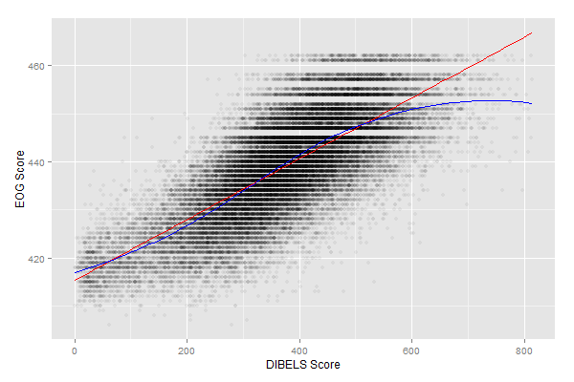

Figure 3: Scatter plots of NC EOG Scaled Scores with TRC Levels
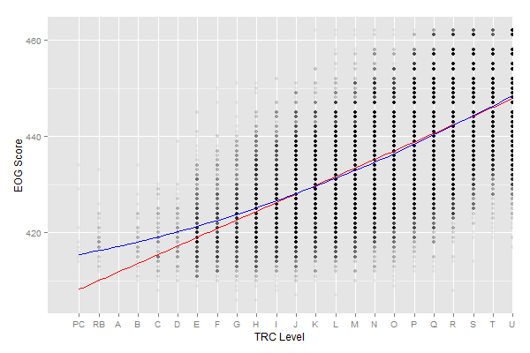

Given the approximately linear relationships between the mCLASS:Reading 3D measures and NC EOG scale scores and the approximately normal distribution of the NC EOG scale scores, it is appropriate to employ DIBELS Next Composite Scores and TRC levels in the following logistic regression model estimating NC EOG proficiency:

NC EOG (Not Proficient or Proficient) = β₀ + β₁(DIBELS) + β₂(TRC)

This model estimates the probability that a student is proficient on NC EOG, given the student’s DIBELS Next Composite Score and TRC level. As shown in Table 8, both DIBELS Next Composite Scores and TRC levels strongly correspond to NC EOG reading performance levels.

Table 8: Logistic Regression Model Coefficients and Statistics
Coefficient | β | SE(β) | Z | p
Intercept | –10.37 | 0.09 | –109.31 | < 0.01
DIBELS Next Composite Score | 0.01 | 0.00 | 70.50 | < 0.01
TRC Level | 0.27 | 0.00 | 58.97 | < 0.01

Estimates of Proficient or Non-Proficient on NC EOG produced by the logistic regression model based on DIBELS Next Composite Scores and TRC levels are found to be correct for 79 percent of students. (Table 9). Finally, of those students whose proficiency was incorrectly estimated, the majority were false negatives (11%), not false positives, meaning that mCLASS: Reading 3D estimated NC EOG performance to be non-proficient when students’ observed performance was, in fact, Proficient (or better).

Table 9: Observed and Predicted NC EOG Proficiency
 | Observed
Predicted | Not Proficient | Proficient
Not Proficient | 47.53% | 10.80%
Proficient | 9.94% | 31.73%

Conclusion
This study examines the concurrent validity of the mCLASS:Reading 3D assessment with respect to the North Carolina End-of-Grade (NC EOG) Reading Comprehension Test. mCLASS:Reading 3D consists of DIBELS Next and the Text Reading and Comprehension (TRC) measures administered at the end of the school year. Correspondence of these two measures with Grade 3 NC EOG performance in spring of the ‘12–‘13 school year was examined.

This study finds that mCLASS:Reading 3D is an effective indicator of NC EOG performance. Students who were non-proficient on both DIBELS Next and TRC were most frequently non-proficient on the NC EOG (96%) while students proficient on both DIBELS Next and TRC were also most often proficient (or above) on the NC EOG (68%). Statistical analysis suggests mCLASS: Reading 3D provides adequate concurrent validity evidence as scores strongly and positively correlate with NC EOG — DIBELS Next demonstrated a correlation of r = 0.74 with NC EOG and TRC correlated with NC EOG at r = 0.71. Lastly, a logistic regression model estimated NC EOG scores from mCLASS: Reading 3D performance — extending interpretation beyond the current administration period and population of students. This statistical analysis demonstrated that the combination of DIBELS Next and TRC has an overall accuracy of 79 percent in estimating proficiency on the Grade 3 NC EOG reading comprehension assessment.

